**DAILY ONLINE ACTIVITIES SUMMARY**

|  |  |  |  |  |  |  |  |  |
| --- | --- | --- | --- | --- | --- | --- | --- | --- |
| **Date:** | **30-06-2020** | | | | | **Name:** | **D Jasmine Joyline** | |
| **Sem & Sec** | **VI Sem A** | | | | | **USN:** | **4AL17CS024** | |
| **Online Test Summary** | | | | | | | | |
| **Subject** | | **-** | | | | | | |
| **Max. Marks** | | **-** | | **Score** | | | **-** | |
| **Pre-placement Training Summary** | | | | | | | | |
| **Course** | 1.JAVA AND J2EE | | | | | | | |
| **Certificate Provider** | | | **-** | | **Duration** | | | **4hr** |
| **Coding Challenges** | | | | | | | | |
| **Problem Statement:**  Write a Java Program to determine whether one string is a rotation of another. | | | | | | | | |
| **Status:Completed** | | | | | | | | |
| **Uploaded the report in Github** | | | | | **Yes** | | | |
| **If yes Repository name** | | | | | <https://github.com/alvas-education-foundation/D_Jasmine_Joyline/tree/master/daily_progress> | | | |
| **Uploaded the report in slack** | | | | | **Yes** | | | |

Online Test Details:

-

Online Training Details:

Attended class on the topic JAVA &J2EE from 9am to 11am

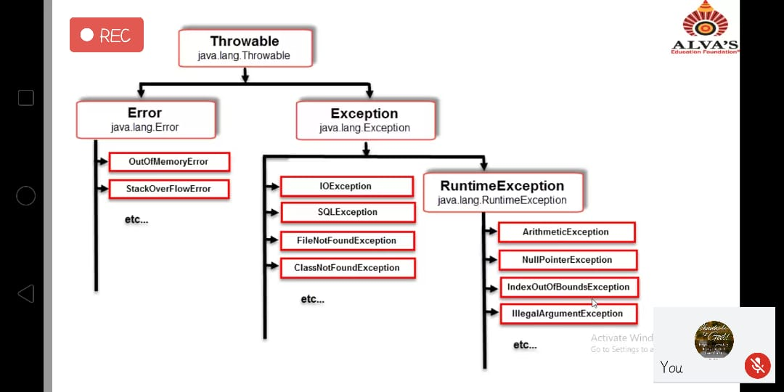

Coding Challenges Details:

Write a Java Program to determine whether one string is a rotation of another.

Description:  
In this program, we need to check whether a string is a rotation of another string or not.

String 1: abcde  
String 2: deabc  
String 1 + String 1: abcdeabcde

Consider the above example, suppose we need to check whether string 2 is a rotation of string 1. To find this, we concatenate string 1 with string 1. Then, try to find the string 2 in concatenated string. If string 2 is present in concatenated string then, string 2 is rotation of string 1. String 2 deabc is found on the index 3 in concatenated string. So, deabc is rotation of abcde.

